# ****umt****

# ****S.E PROJECT****

SUBMITTED BY:

***SUBHAN SHAHNAWAZ (F2023266119)***

1. ***UZAIR AJMAL (F2023266125)***

***M. UMAIR ZAHID (F2023266127)***

***UMER ISLAM (F2023266112)***

SUBMITTED TO:

**PROF. SHAHBAZ QADEER**

# ****Autonomous Drone System for Real-Time Disaster Response****

### ****Software Overview:****

The Autonomous Drone System for Real-Time Disaster Response (ADSRR) is an intelligent, decentralized platform designed to manage and deploy a fleet of drones in disaster-stricken areas. The system aims to provide real-time situational awareness, assess damage, detect survivors, and relay critical data to emergency response teams. Using reinforcement learning, computer vision, and optimized path finding algorithms, the drones operate collaboratively, making this system suitable for large-scale and rapidly evolving environments.

****Stakeholders:****

1. **Emergency Response Teams**
2. **Disaster Management Authorities**
3. **System Operators**
4. **Data Analysts**
5. **System Developers and Engineers**
6. **Survivors and Affected Individuals**
7. **Government Agencies**
8. **Funding Bodies**
9. **Local Communities**

## PROJECT DETAILS:

1. **Introduction**
2. **System Architecture**
3. **Main Component**

* Drone Management and Communication
* Real-Time Path Optimization
* Computer Vision for Object Detection
* Emergency Data Processing and Reporting

1. **System Modules and Their Functionality**
2. **Data Flow and Communication Protocols**
3. **System Algorithms**
4. **Challenges and Solutions**
5. **Deployment and Testing Plan**
6. **Security and Privacy Measures**
7. **Conclusion and Future Work**

### ****1.Introduction****

The ADSRR aims to assist first responds by rapidly assessing disaster areas. The system consists of a fleet of drones that autonomously perform tasks such as area scanning, object detection (e.g., survivors, debris), and hazard identification (e.g., fires, floods). These drones can communicate with each other and a central command hub, leveraging AI to make autonomous decisions and provide real-time data.

### ****2.System Architecture****

The ADSRR system architecture is designed for robustness and scalability, consisting of the following primary layers:

* **Control Center Layer**: A command interface for emergency responders to deploy drones, view data, and direct the fleet’s actions.
* **Drone Fleet Layer**: Consisting of autonomous drones equipped with sensors, cameras, GPS, and processing units to execute missions.
* **Communication Layer**: A real-time, low-latency communication network allowing data exchange among drones and with the control center.
* **Cloud Processing Layer**: For real-time data analysis, storage, and processing of large data sets from multiple drones.

### ****3.Core Components****

#### Drone Management and Communication

* **Fleet Management**: The control center manages the drone fleet by dynamically assigning tasks based on real-time conditions and mission requirements.
* **Communication Protocol**: Drones use mesh networking for inter-drone communication, sharing location, speed, altitude, and mission status, ensuring data redundancy and reliability.
* **Real-Time Data Relay**: Data collected by each drone is relayed to the control center, where it is processed for situational awareness.

#### Real-Time Path Optimization

* **Path finding Algorithms**: Drones use reinforcement learning algorithms to optimize paths and avoid obstacles. Algorithms like A* and RRT (Rapidly-exploring Random Tree) ensure efficiency in dynamic environments.
* **Collaborative Path finding**: Drones avoid overlapping paths and maximize area coverage, avoiding resource wastage and ensuring efficient resource use.

#### Computer Vision for Object Detection

* **Survivor Detection**: Using deep learning-based object detection (YOLO, Faster R-CNN), the drones identify human figures in distress.
* **Hazard Identification**: The vision system detects fires, flooded areas, debris, and other hazards using object classification and semantic segmentation.
* **Thermal Imaging**: Drones equipped with thermal cameras detect heat signatures to locate survivors or hot zones in disaster areas.

#### Emergency Data Processing and Reporting

* **Real-Time Analytics**: Data processing pipelines filter critical data, including potential survivor locations, structural damage, and hazard zones.
* **Priority Classification**: Using image classification and NLP on emergency signals (e.g., SOS signs), drones prioritize urgent cases and relay them immediately to responders.
* **Report Generation**: The system compiles a comprehensive report, summarizing potential risks, required resources, and recommended responders actions.

### ****4. System Modules and Their Functionality****

#### Drone Autonomous Control Module

* **Mission Planning**: Automatically assigns tasks based on the disaster map and predefined areas of interest.
* **Dynamic Path Adjustment**: Real-time path recalibration based on evolving data, such as new hazards or blocked routes.

#### Data Collection Module

* **Visual Data**: Captures and processes images and videos for situational awareness.
* **Sensor Data**: Captures temperature, air quality, and other environmental factors.

#### AI-Based Decision Module

* **Decision-Making Model**: Integrates reinforcement learning to adapt strategies for disaster situations (e.g., focusing on fire-affected zones in a wildfire).
* **Object Detection Models**: Trained on disaster-specific data sets to improve accuracy for detecting survivors, vehicles, and common debris types.

#### Communication and Coordination Module

* **Data Synchronization**: Synchronizes data among drones to ensure accurate real-time positioning.
* **Central-Drone Communication**: Manages requests, status updates, and mission data from drones.

### ****5.Data Flow and Communication Protocols****

* **Low-Latency Data Streaming**: Real-time data transmission protocol (e.g., WebRTC) for fast video and telemetry streaming.
* **Inter-Drone Messaging**: Peer-to-peer communication allows drones to share hazard locations, survivor coordinates, and areas covered.
* **Cloud Integration**: Data backup on cloud servers, allowing real-time and historical data access for the control center.

### ****6. System Algorithms****

#### Path Optimization and Obstacle Avoidance

* **Reinforcement Learning**: Drones learn optimal paths by simulating various disaster scenarios and adapting to terrain.
* **Multi-Objective Optimization**: Balances multiple objectives (e.g., area coverage, fuel efficiency, obstacle avoidance).

#### Survivor and Hazard Detection

* **Object Detection**: Trained convolutional neural networks (e.g., YOLOv5) for real-time detection.
* **Heat Mapping**: Identifies and localizes heat sources through thermal imaging, analyzing pixel-by-pixel heat distribution.

#### Data Aggregation and Reporting

* **Data Prioritization**: Aggregates critical findings and classifies data by urgency.
* **Predictive Analytics**: Uses pattern recognition to predict areas that might become hazardous, based on weather patterns and environmental data.

### ****7. Challenges and Solutions****

* **Communication in Remote Areas**: Using mesh networking and satellite links as backup communication channels to maintain real-time data flow.
* **Battery and Power Constraints**: Implementing an energy-efficient flight mode and automatic battery exchange at designated charging stations.
* **Accuracy in Hazard Detection**: Enhancing detection by fine-tuning computer vision models on disaster-specific data sets.

### ****8. Deployment and Testing Plan****

#### Simulation and Testing

* **Virtual Simulations**: Use of drone simulation software to test flight, path finding, and disaster response capabilities in virtual environments.
* **Controlled Environment Testing**: Testing in mock disaster sites with dummy targets and hazards.

#### Real-World Deployment

* **Pilot Program**: A small-scale deployment in a specific area to evaluate the system's response in a real environment.
* **Feedback Loops**: Continuous improvement based on data and feedback from disaster response teams and real-time data analysis.

### ****9. Security and Privacy Measures****

* **Data Encryption**: Encrypt all communication and data storage to prevent unauthorized access.
* **Access Control**: Role-based access control for responders and drone operators.
* **Secure Data Sharing**: Data sharing with third parties (e.g., government agencies) is done via secure protocols only.

### ****10. Conclusion and Future Work****

* **Achievements**: Overview of project capabilities, including real-time response efficiency, collaborative coverage, and accurate detection.
* **Future Enhancements**: Adding advanced sensors (e.g., LiDAR) for better terrain mapping, further optimization of AI-based decision-making, and expansion to multiple disaster types.
* **Real-World Implications**: Potential impact of ADSRR on future disaster response, and how this system can reduce human risk while providing comprehensive situational awareness.

#### ****User Requirements:****

1. **Autonomous Disaster Response**: The system should deploy drones autonomously for rapid disaster assessment and situational awareness.
2. **Real-Time Analytics**: Provide live updates to emergency responders about survivors, hazards, and structural damage.
3. **Collaborative Operation**: The drones should work together efficiently, avoiding redundant tasks and covering the maximum area possible.
4. **Accurate Object and Hazard Detection**: High precision in detecting survivors, debris, fires, and flooded areas.
5. **Secure Communication**: All data exchanges must be secure to protect sensitive disaster information.
6. **Scalability**: The system should scale to large-scale disaster scenarios, handling multiple drones effectively.
7. **User Interface for Control**: A user-friendly interface for managing drones and visualizing disaster response in real time.

#### ****System Requirements:****

1. **Hardware Requirements:**
   1. Drones equipped with sensors (thermal, GPS, environmental).
   2. Cameras for visual data capture and computer vision tasks.
   3. Central processing units capable of handling real-time data.
   4. Charging stations or battery swap mechanisms.
2. **Software Requirements:**
   1. Reinforcement learning for path optimization.
   2. Object detection algorithms (e.g., YOLO, Faster R-CNN).
   3. Real-time communication protocols (e.g., WebRTC).
   4. Data storage and processing in the cloud.
3. **Performance Requirements:**
   1. Low latency in data transmission.
   2. Robust obstacle avoidance and adaptive path finding.
   3. Efficient resource use to extend drone operational time.

**4. Security and Privacy Requirements:**

* 1. Encrypted data communication and storage.
  2. Role-based access control for system users.
  3. Secure APIs for data sharing.

**5. Integration and Deployment Requirements:**

* 1. Compatibility with existing disaster response systems.
  2. Modular architecture for future upgrades.

### Functional Requirements:

1. **Autonomous Disaster Response**
2. **Real-Time Analytics**
3. **Collaborative Drone Operation**
4. **Secure Communication**
5. **User-Friendly Interface**

### Non-Functional Requirements:

1. **Performance**
2. **Scalability**
3. **Reliability**
4. **Energy Efficiency**
5. **Security**
6. **Compatibility**

***CLASS DIAGRAM:***

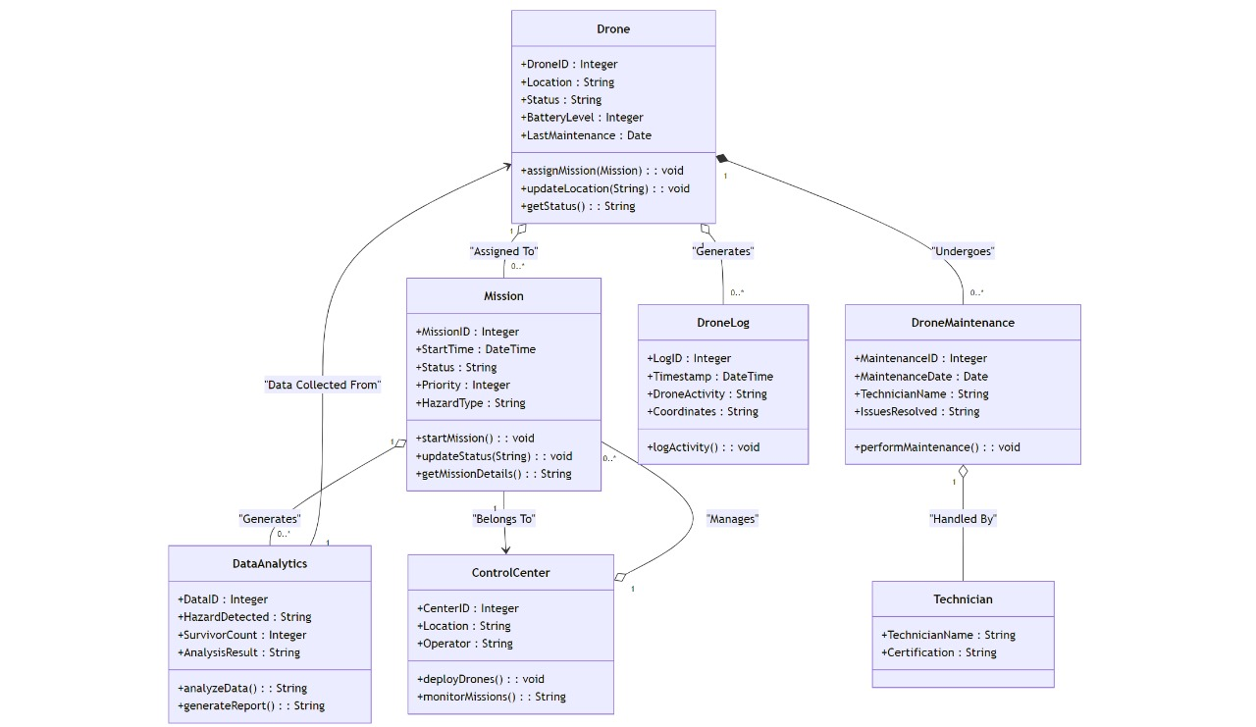

***SEQUENCE DIAGRAM:***

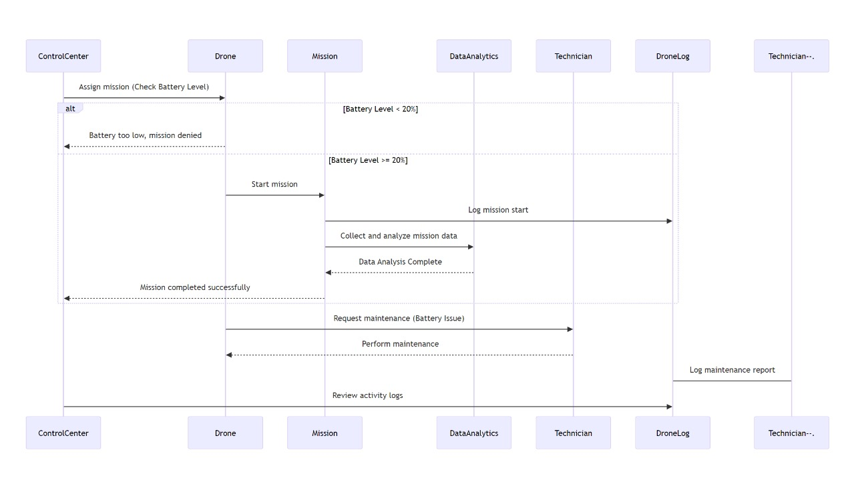

***ERD DIAGRAM:***

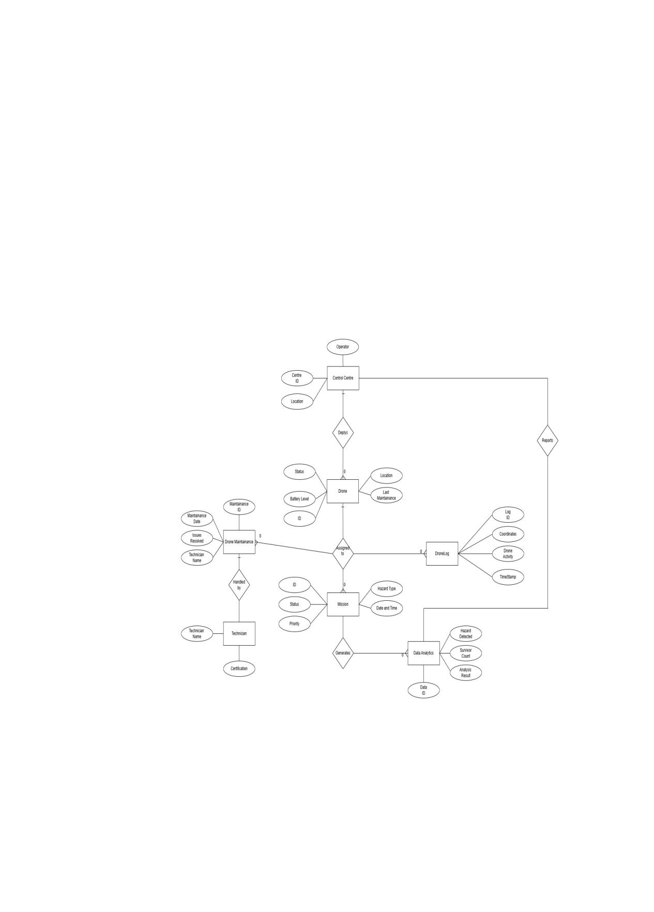

***USE CASE:***

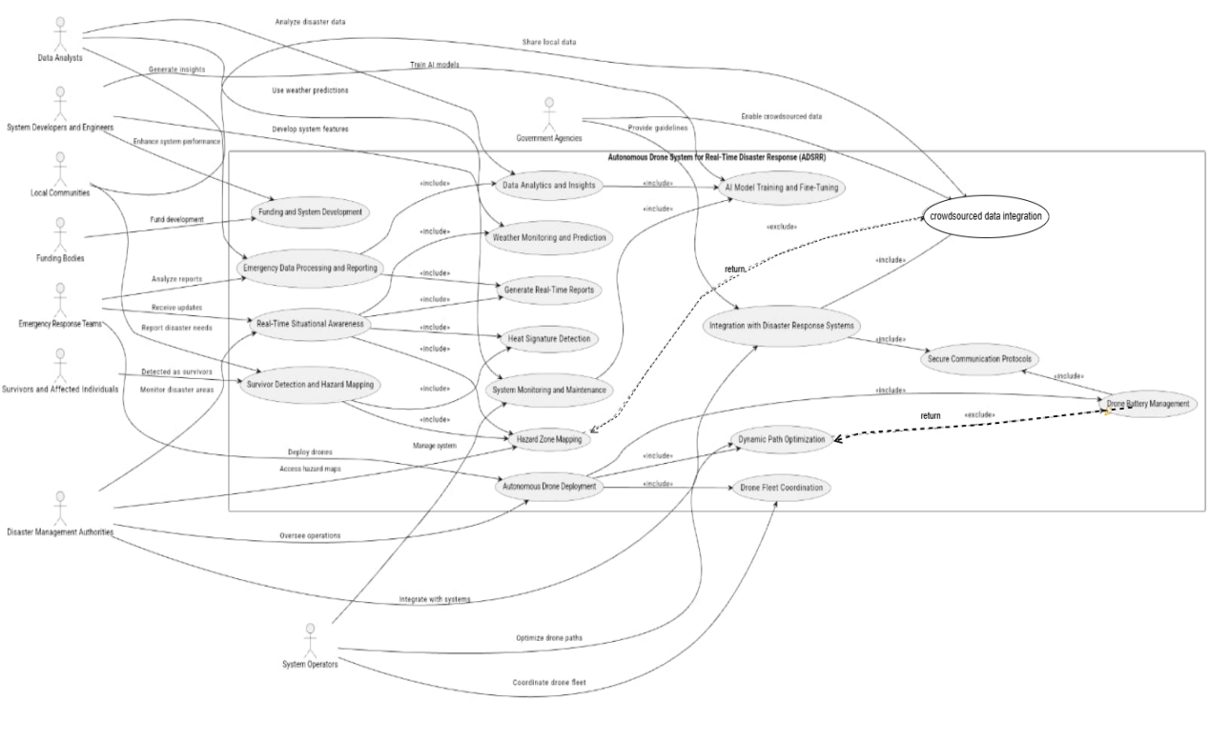

***ACTIVITY DIAGRAM:***

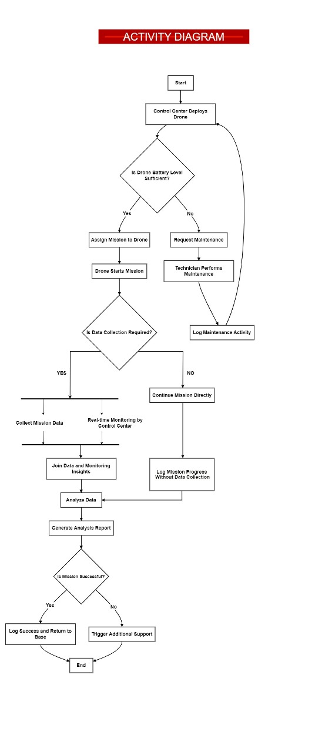

***DATA FLOW DIAGRAM:***

***LEVEL 0:***

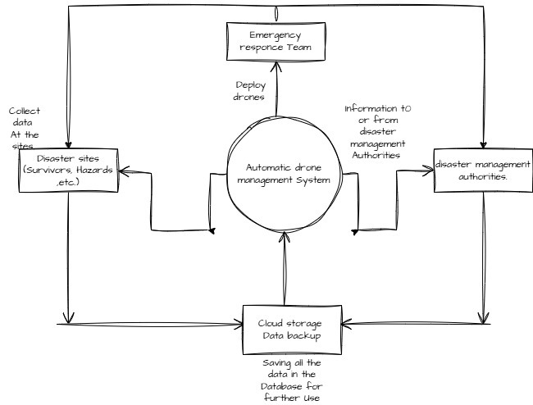

***GANTT CHART:***

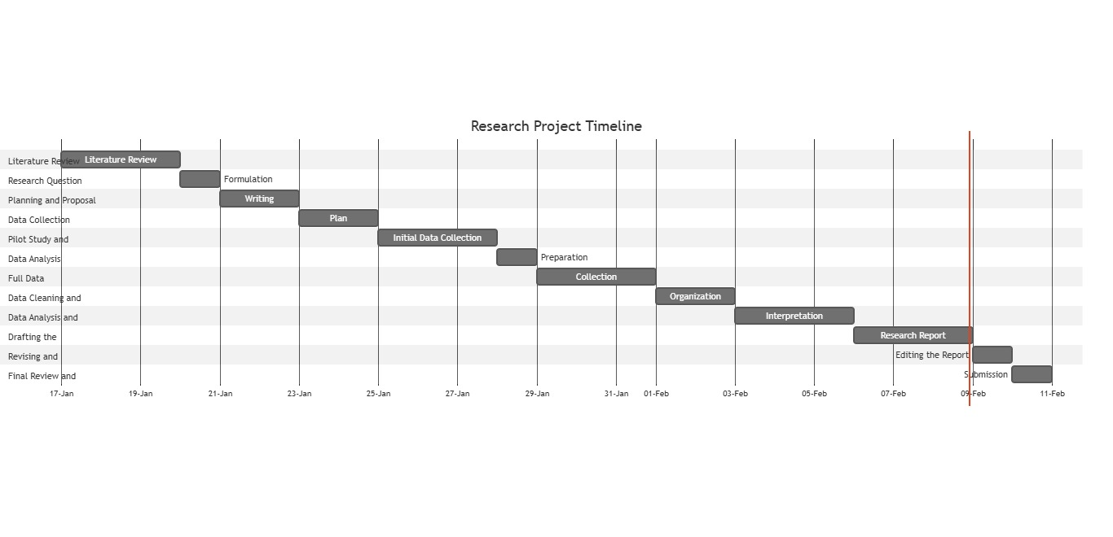

***STATE DIAGRAM:***

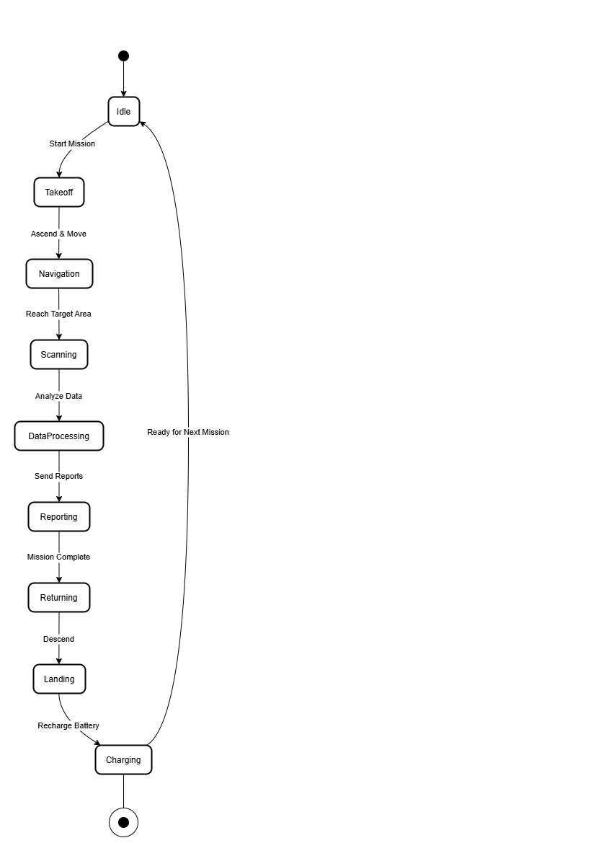

***DATA FLOW DIAGRAM:***

***LEVEL 1:***

